ID NUM : 2200031128 CH.BHAVANA
Spring Data JPA - Quick Example
TASKS :
- Create a Project using Spring Initializr
- Country table creation
- Persistence Class - com.cognizant.orm-learn.model.Country
- Repository Class - com.cognizant.orm-learn.CountryRepository
- Service Class - com.cognizant.orm-learn.service.CountryService
- Testing in OrmLearnApplication.java
Codes:
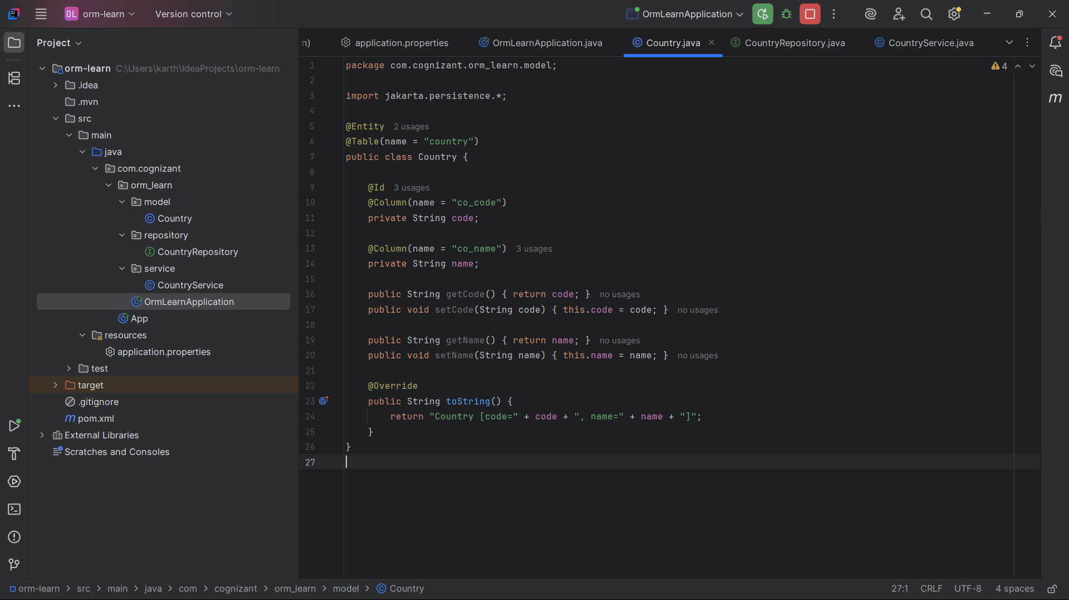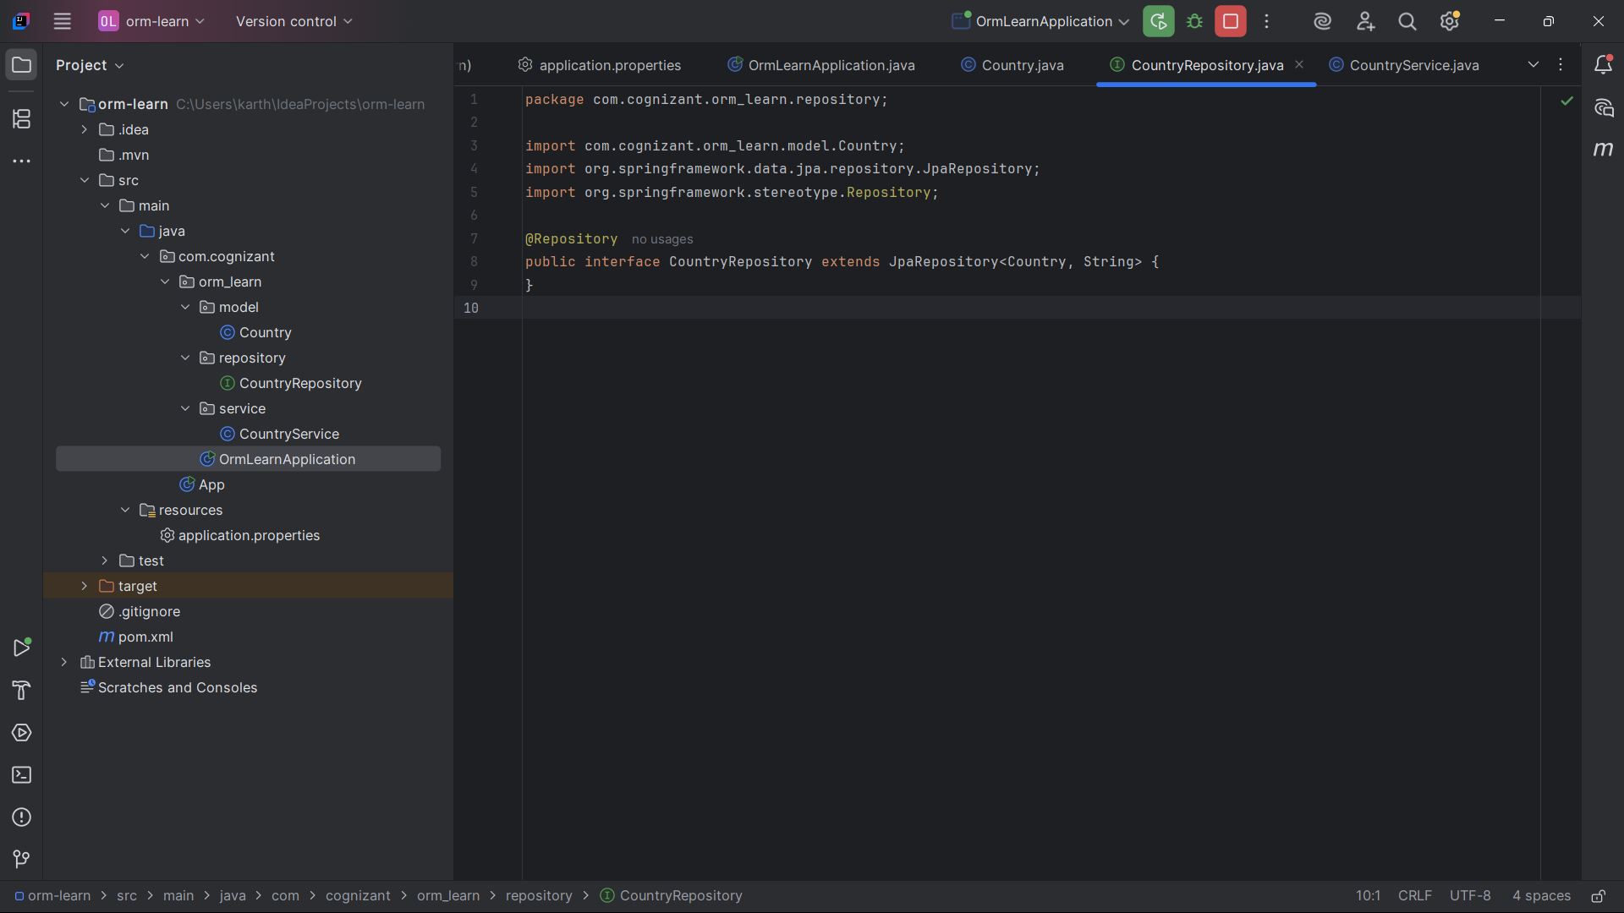
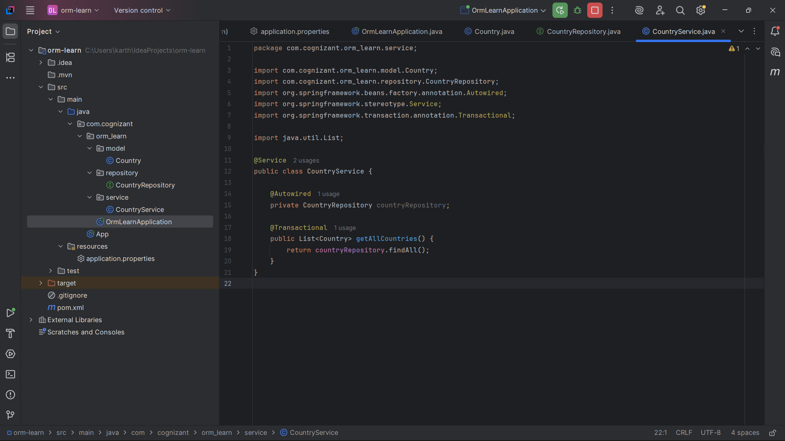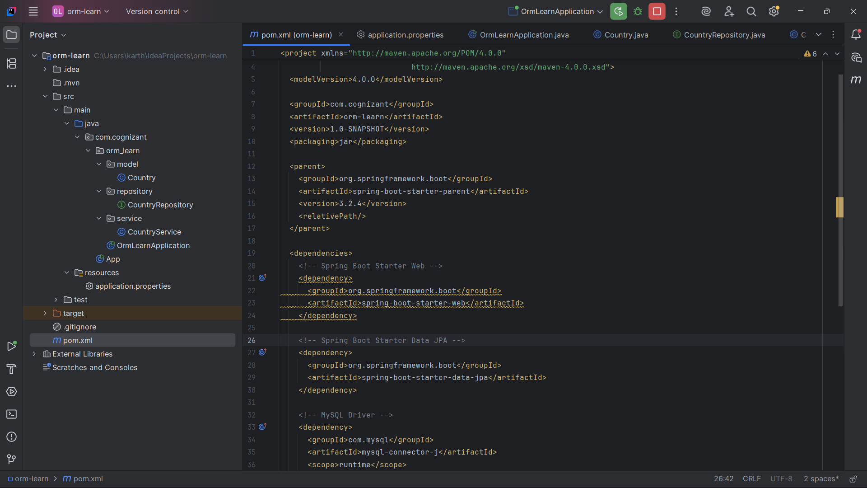

Main Code:
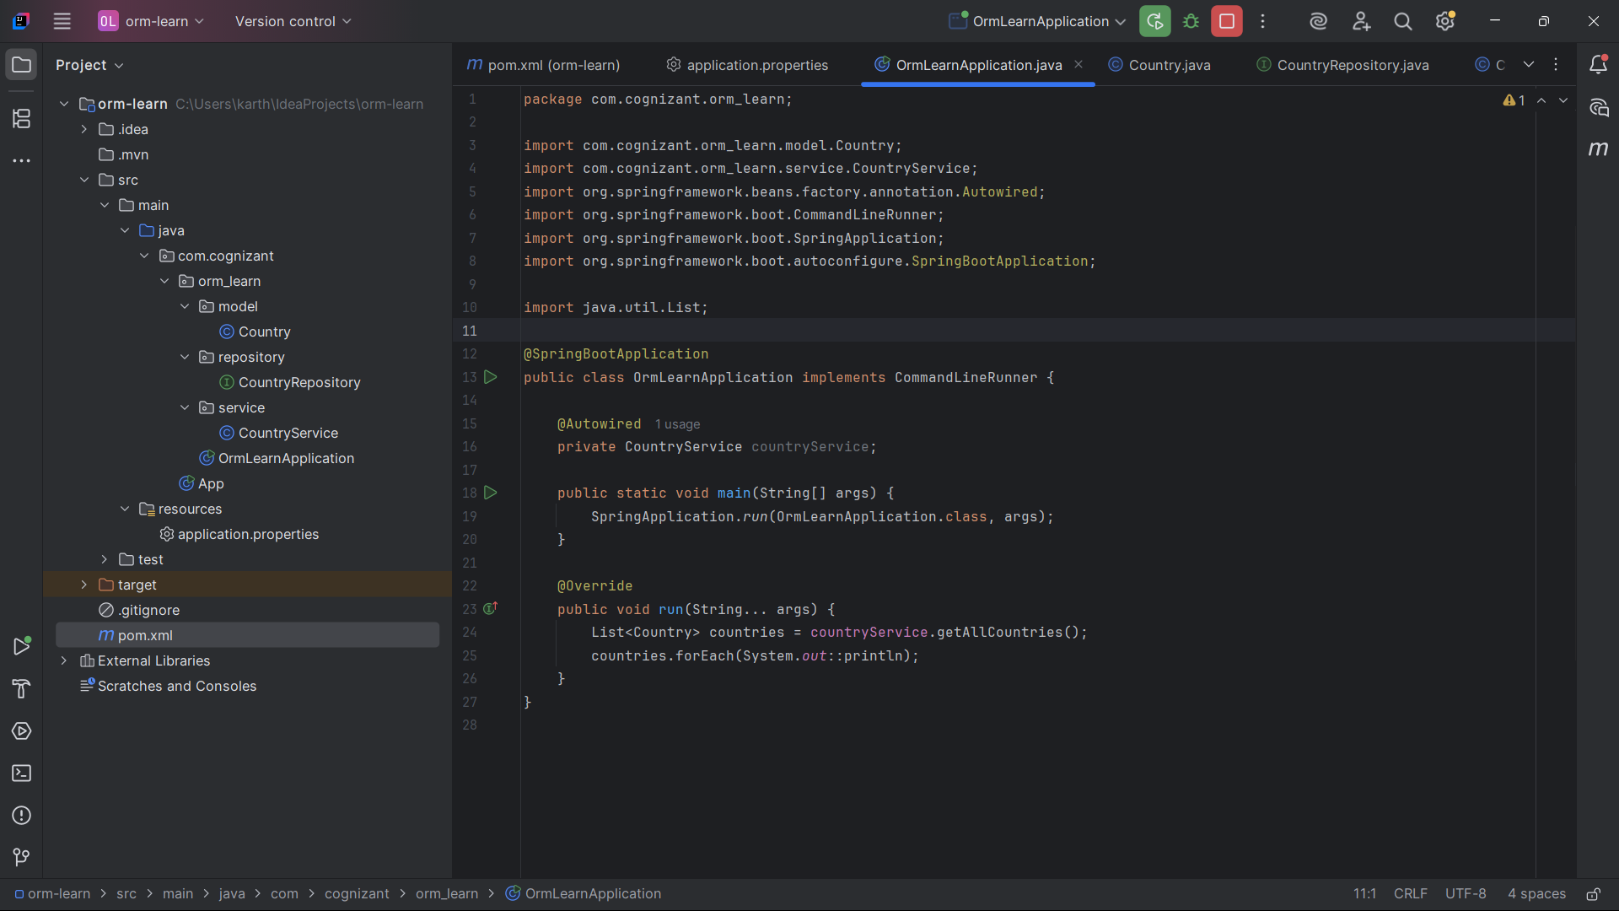
Database creation:
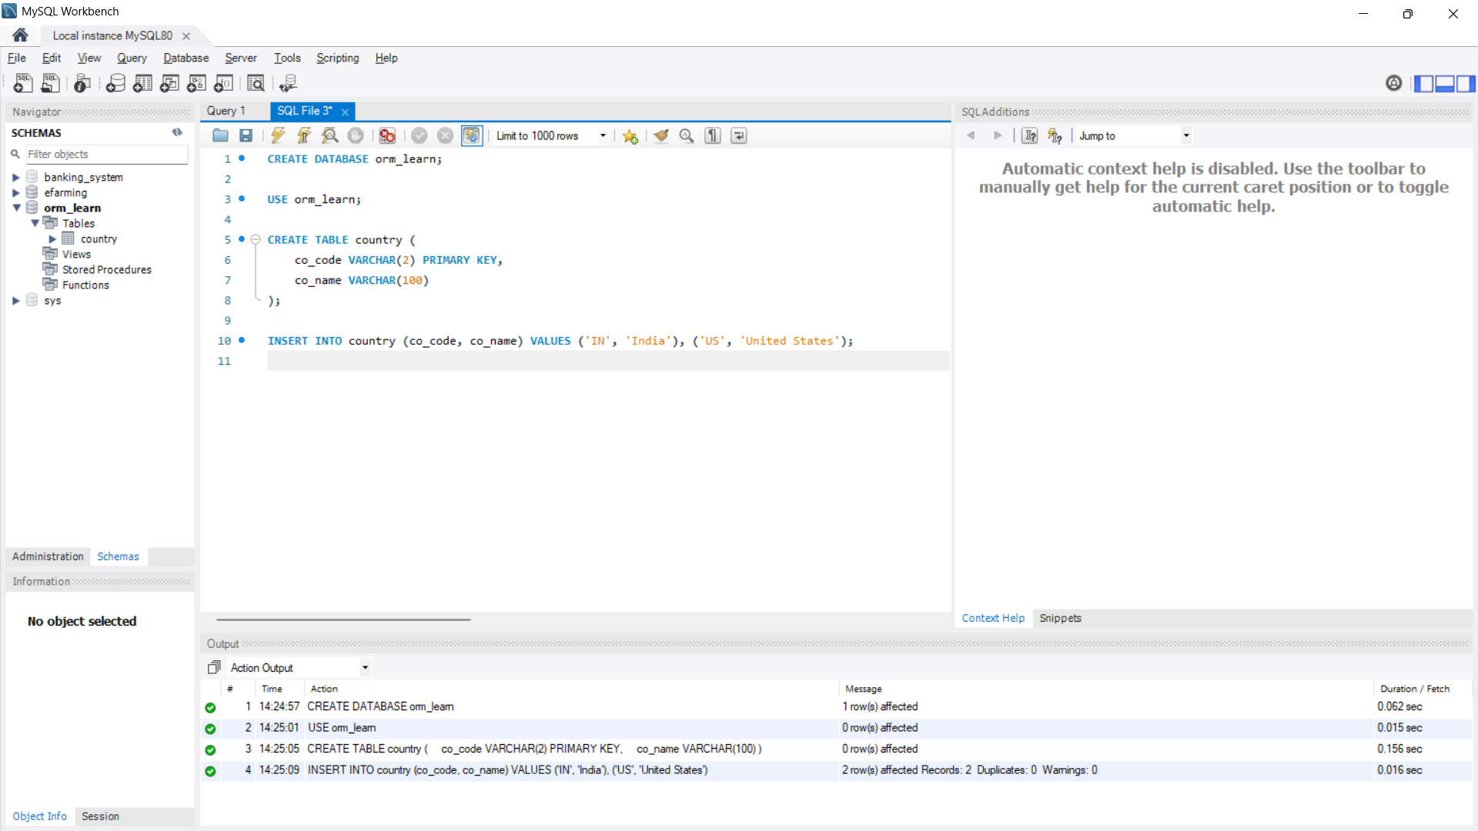

Output:
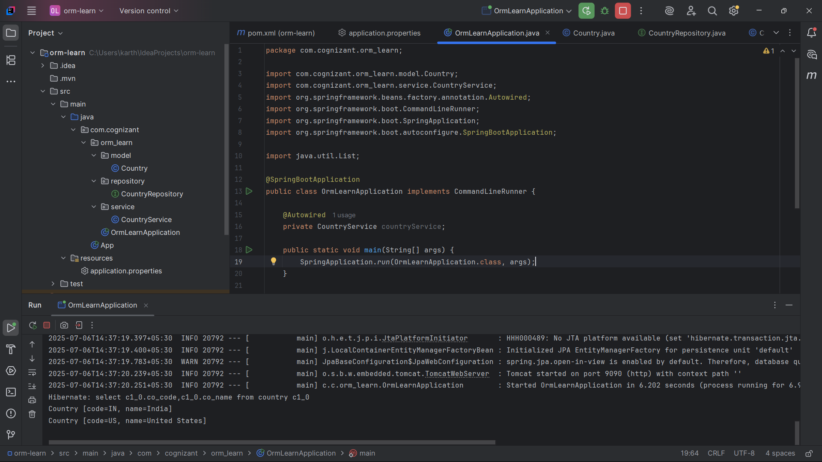
Difference Between JPA, Hibernate, and Spring Data JPA
Feature / Aspect | JPA (Java Persistence API) | Hibernate | Spring Data JPA
Type | Specification/API | Framework / Implementation of JPA | Spring module built on JPA + Hibernate
Maintained By | Jakarta EE (formerly Java EE) | Red Hat | Spring Framework Team
Purpose | Standard for ORM in Java | Provides ORM functionality | Simplifies JPA by reducing boilerplate
Implements/Uses | Interfaces like EntityManager | Implements JPA spec + own features | Uses JPA and Hibernate internally
Requires Implementation? | ✅ Yes | ❌ No (is itself an implementation) | ✅ Yes (uses Hibernate or other JPA impl)
Boilerplate Code | ✅ Yes (manual queries, entity manager) | ✅ Yes | ❌ No (auto-generates repositories)
Repository Support | ❌ Not provided | ❌ Not provided | ✅ Interfaces like JpaRepository
Query Language | JPQL | JPQL + Native SQL + HQL | Method naming (findByName) + JPQL
Ease of Use | Medium | Medium to High | ✅ Very High
Caching | ❌ Not defined | ✅ Built-in | ✅ Inherited from Hibernate
Learning Curve | Moderate | Moderate to High | ✅ Beginner-friendly

